

REPUBLIC OF TURKIYE
ESKISEHIR OSMANGAZI UNIVERSITY
INSTITUTE OF HEALTH SCIENCES

GRADUATE DISSERTATION WRITING GUIDE

ESKISEHIR-2022
FOREWORD
The Dissertation Writing Guide (DWG) of the Institute of Health Sciences of Eskişehir Osmangazi University (IHS) has been updated by the members of the IHS Board of Directors with the resolution of the Board of Directors dated ……….. under number ………. . The new guide, which was updated in accordance with the opinions and suggestions submitted to the Institute, was adopted by the Board of Directors' resolution dated ………. and numbered ……….. The updated Dissertation Writing Guide (ESOGÜ.SBE. -TYK 2021) applies to students who will take the thesis defense examination after 02/01/2021. Theses and term papers accepted after this date must be written according to the new guide. The Guide for Thesis Writing at the Institute of Health Sciences has been updated with input from SBE Board members …………………………………………………………. .

Eskisehir Osmangazi University
Institute of Health Sciences
Directorate

INDEX
1.PURPOSE 1
2.THESIS FEATURES 1
2.1. Paper 1
2.2. Cover and Binding 1
2.3. Printing 1
3.FEATURES OF THE TEXT 4
3.1. Expression 4
3.2. Page layout 4
3.3. Line Spacing 5
3.4. Numbering of the pages 7
3.5. Tables and Figures 7
3.6. Icons and Abbreviations 9
3.7.Footnotes 10
3.8. Citations 10
4.SECTIONS OF THE THESIS 10
4.1. Front Section 11
4.1.1. Outer cover 11
4.1.2. Inner cover 11
4.1.3. Acceptance and confirmation page 12
4.1.4.Ethicccal statement……………………………………………….......…...14
4.1.5. Acknowledgement page 13
4.1.6. Abstract and Turkish Summary 14
4.1.7. Indexes 17
4.1.7.1. Tables of contents 17
4.1.7.2. Index of symbols and abbreviations 19
4.1.7.3. Index of illustrations 20
4.1.7.4. Index of tables 20
4.2. Main Section 21
4.2.1. Introduction and Aim Section 21
4.2.2. General Information Part 21
4.2.3. Material and Methods Section 22
4.2.3.1. Ethics Committee Approval of the Study 22
4.2.3.2. Nature of the research 22
4.2.3.3. The population and sample/study groups of the research 22
4.2.3.4. Research procedures 22
4.2.3.5. Variables of the study 24
4.2.3.6. Analysis of the data 24
4.2.3.7. Limitations of the study 24
4.2.4. Results section 24
4.2.5. Discussion Section 25
4.2.6. Conclusion and Recommendations Section 25
4.3.LAST SECTION 26
4.3.1. References 26
4.3.1.1. Insertion of references in the text (citation format) 26
4.3.2.2. Writing the References in the Bibliography Index 28
Appendices 32

- PURPOSE
The Institute of Health Sciences of Eskişehir Osmangazi University was established to provide qualitative and formal standardization in the preparation, writing and printing of master's and doctoral theses. Students who are going to write a master's and doctoral thesis are obliged to follow these rules for thesis writing from the specified date.

- THESIS FEATURES
2.1. Paper
80-100 grams of first pulp white paper should be used in the writing and printing of the theses to be prepared. The papers to be used should be in A4 (210x297 mm) size. After binding and cutting, the final dimensions of the theses should be 205x290 mm.

2.2. Cover and Binding
Outer Binding: The outer binding should be prepared according to the example shown in Figure 1. The cover should be white coated cardboard and 210x297 mm in size. For the back cover, you should use a plain cardboard of the same type and color.
Inner cover: The inner cover should be prepared according to the example shown in Figure 2. A blank page should be inserted between the outer cover and the inner cover and between the last page of the dissertation and the back of the outer cover.
2.3. Printing
Dissertations should be printed using a laser printer or a laser quality printer. The printed thesis should be submitted to IHS along with an electronic file in PDF format. It is recommended to use advanced word processing programs (Microsoft Office Word®, Word Perfect®) when writing theses.

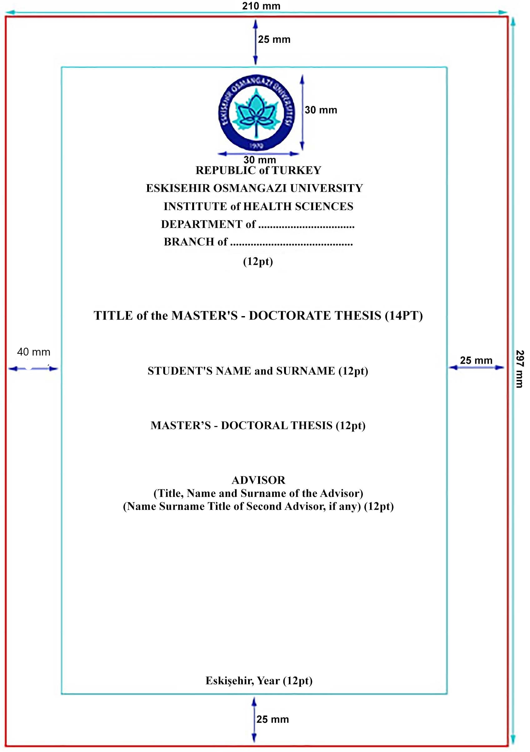
Single line spacing Bold
Two lines spacing
The bottom line of the page
Two lines spacing
Two lines spacing
Two lines spacing
Figure 1. Outer binding design
Note: Frames are set to show the page structure and margins of the text. Do not use frames on the cover of the dissertation!

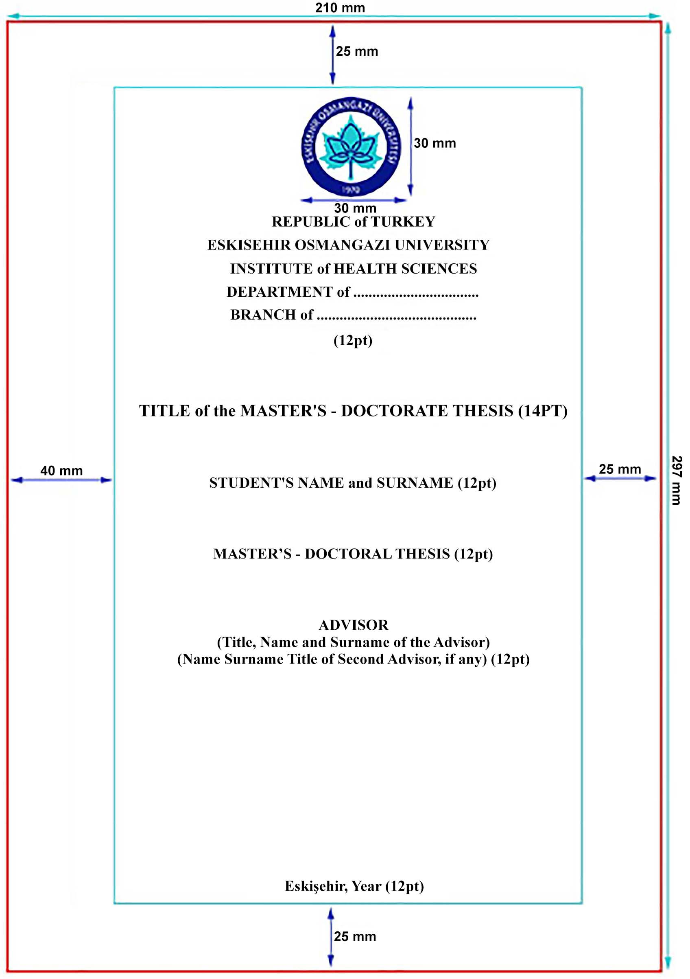
Single line spacing Bold
Two lines spacing
The bottom line of the page
Two lines spacing
Two lines spacing
Two lines spacing
Figure 2. Inner cover design.

Note: Frames are set to show the page structure and margins of the text. Do not use frames on the cover of the dissertation!

3. FEATURES OF THE TEXT
Dissertation chapters should be written according to the writing rules of APA 7.0 (The American Psychological Association) or ICMJE (International Committee of Medical Journal Editors).
3.1. Expression
Dissertations should be written in simple, understandable, scientific language and in English with expression that can be understood by all equally. The text should be written in accordance with English grammar rules, using passive words in the third person (done, seen, etc.). The use of foreign words that have not been translated into English should be avoided as far as possible.
3.2. Page layout
Space should be left 2.5 cm from the top margin, 4 cm from the left margin, 2.5 cm from the right margin, and 2.5 cm from the bottom margin. Text and title of the paper should be aligned on the right and left margins. The prepared text block should not extend beyond its frame. Explanations of tables and figures should be written centered. Page numbers should be 1.25 cm from the bottom margin and aligned on the right. The page layout is shown in Figure 3.
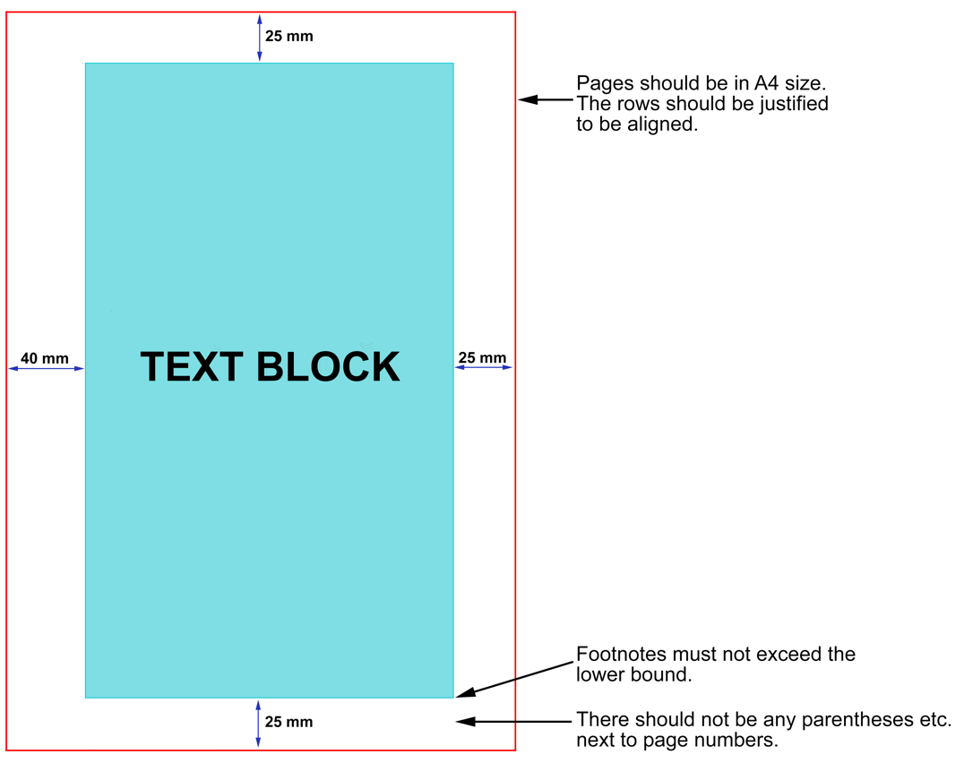
Figure 3. Page layout
3.3. Line Spacing
Dissertations should be written in simple scientific language and in English with expression that is equally understandable to all. Spelling that conforms to English spelling rules should be used.
Times New Roman font is used in all parts of the paper. The text of the thesis includes the contents, the headings, the explanatory notes to the tables and figures, and all other parts except the footnotes. The text of the thesis is written in 12 pt (font size). 1 (one) space is left after the punctuation marks. A line spacing of 1.5 is used between paragraph lines in the text of the thesis.
Leave 6 pt space before and after the paragraph between the subsection headings and their first paragraphs, and between the other paragraphs of the text.

Paragraph beginnings should start 1 cm further in.
Numbers up to 10 in the text should be written, larger numbers figures. Numbers per sentence should be written.
Smaller characters may be used in tables and figures that fit on a single page.
A space of 6 pt should be maintained between the main text and figures, tables and formulae.
Except for date and institution abbreviations, lines should not begin with numbers, abbreviations, symbols, and characters. Numbers with four or more digits are written in groups of three, counted from the end, and a period is placed between them. (1.483; 628.524; 50.348.975; 74.545.300.621.350, etc.) Fractions in numbers are separated by commas [27,3 (27 whole, 3 decimal); 7,84 (7 whole, 84 percent), etc.].
In the Turkish abstract part, in accordance with the standards of APA, only one dot (.) should be used when writing decimal numbers. When writing large numbers, you should group them into groups of three, starting from the last digit of the number, and separate these groups with commas (,).
First degree chapter headings, approval, explanation, acknowledgements, summary, English summary, all indexes, and references should be at the top of the page. Main section headings and subheadings should be bolded; minor headings within the section should be italicized. All main section headings and the first letter of each word of subheadings should be capitalized. Conjunctions such as "and, or, and with" in second- and third-degree headings should be lower case. If additional subheadings are required, they should be italicized and bolded, with the first letter of all words capitalized, within 1 cm, and without numbering.
Table 1. Rules for Chapter Titles
Bölüm Başlıkları | Başlık
First order chapter titles | APPROVAL, ETHICAL STATEMENT, ACKNOWLEDGMENTS, SUMMARY, ENGLISH SUMMARY, INDEX, REFERENCES, left, bold, each letter of words in 14 pt.  MAIN SECTION TITLES (INTRODUCTION and PURPOSE, GENERAL INFORMATION, MATERIAL and METHODS, RESULTS, DISCUSSION, CONCLUSION, SUGGESTIONS, REFERENCES and APPENDICES) are written in bold, each letter of words upper capital, 12 pt, left justified.  (Each must start on a new page)
Second order chapter titles | The first letter of each word is capitalized, the others are lowercase, 14 pt and bold, left justified.
Third order chapter titles | The first letter of the first word is capitalised, all other words are lowercase and bold, 12 pt, aligned with a heading
Fourth degree and more subdivision titles | The first letter of the first word is capitalised, all other words are lowercase, bold and italicised, 12 pt, aligned with a heading
At the end of the page there should be at least two lines under the headings, otherwise a new page should be started.
When writing the bibliography, single line spacing should be used and 6 nk space should be left between references.

3.4. Numbering of the pages
The abstract, summary, table of contents, list of figures, list of tables, and list of symbols and abbreviations should be written in small Roman numerals as i, ii, iii, iv, v, ... ; page numbering should be written as 1, 2, 3, ... starting with the "Introduction and Purpose" section. Page numbers should be written in the font used in the text, centered at the bottom of the pages. Characters such as parentheses or hyphens should not be used next to page numbers. The inside cover should not be numbered; the page number should begin with the summary.
3.5. Tables and Figures
Tables and figures should convey the work better than prose to facilitate written expression, and unnecessary figures and tables should be avoided. Figures (graphs, charts, photographs, etc.) and all lines, signs, symbols, numbers, and text on the figure should be produced using a computer printer, Rapido, or Letraset sticker. Such characters, text, or symbols should be typed in 10 pt. If an illustration contains more than one element, each element should be symbolized as A, B, C, ... symbolized, each should be given a figure number, and each element should be described separately. Photographs of patients or volunteers may be used in a way that does not reveal their identity (e.g., by masking their eyes). Non-digital photographs must be printed in color or black and white and be a minimum size of 9x13. Prints on matte board should be preferred. Photographs in work submitted to the judges may be black and white or digital prints incorporated into the text. However, 2 of the copies submitted to the Institute must contain original photographs. The photographs should be printed on thin photographic paper to avoid the formation of bubbles in the work. Photographs may be printed directly on the page by transferring them to the computer, provided that print quality and detail are not lost.
Figures and tables should be placed on the page where they appear in the text, or on the next page, and in such a way that the space to be left on the page does not overflow. A space of 12 pt should be left between the table or figure (including its explanatory notes) and the top and bottom text. Table explanations should be placed above the table and a space of 6 pt should be left between the last line of the table description and the top of the table.
Tables and figures should be numbered separately according to the sections. The numbering of the tables should be in two digits and the table numbers should be in bold. (Table 1.1., Table 2.1., Figure 1.1., Figure 2.1.), then the first letter of the title should be capitalized followed by a lower-case letter. If the title does not fit on the first line, the following line should be on the same level as where the title begins. The first number indicates the title of the main section, while the second number indicates the sequence number of this table within the section. Explanations of tables and figures in the text should be provided by citing the table and figure numbers. Citations from other sources should be given as a permission note or source footnote.
The name of the table should be above the table, and the name of the figure should be below the figure. Figure descriptions should be written below the figure and a space of 6 pt should be left between the description below the figure and the bottom of the figure.
The titles of tables and figures should match the lists of tables and figures in the table of contents. Each figure and table must be cited in the text.
Figures, tables, and their explanations should be placed on the first page of the paper or on the next page, and should be placed so that they do not encroach on the margins. Tables larger than one page should be split to one page size (in an appropriate place). The continuation of the table should be given the same table number and title on the next page, but the phrase "continuation" should be written in parentheses after the table number. The table header should also be moved to the second page.
Formulas must have their own numbering system. When numbering formulas, the phrase "formula" should not be at the beginning of the number and should be numbered according to the order in the section. Formula numbering should be in parentheses on the line containing the formula, 2.5 cm from the right margin of the page. However, if it is mentioned in the text, it should be written as "Formula 2.1".

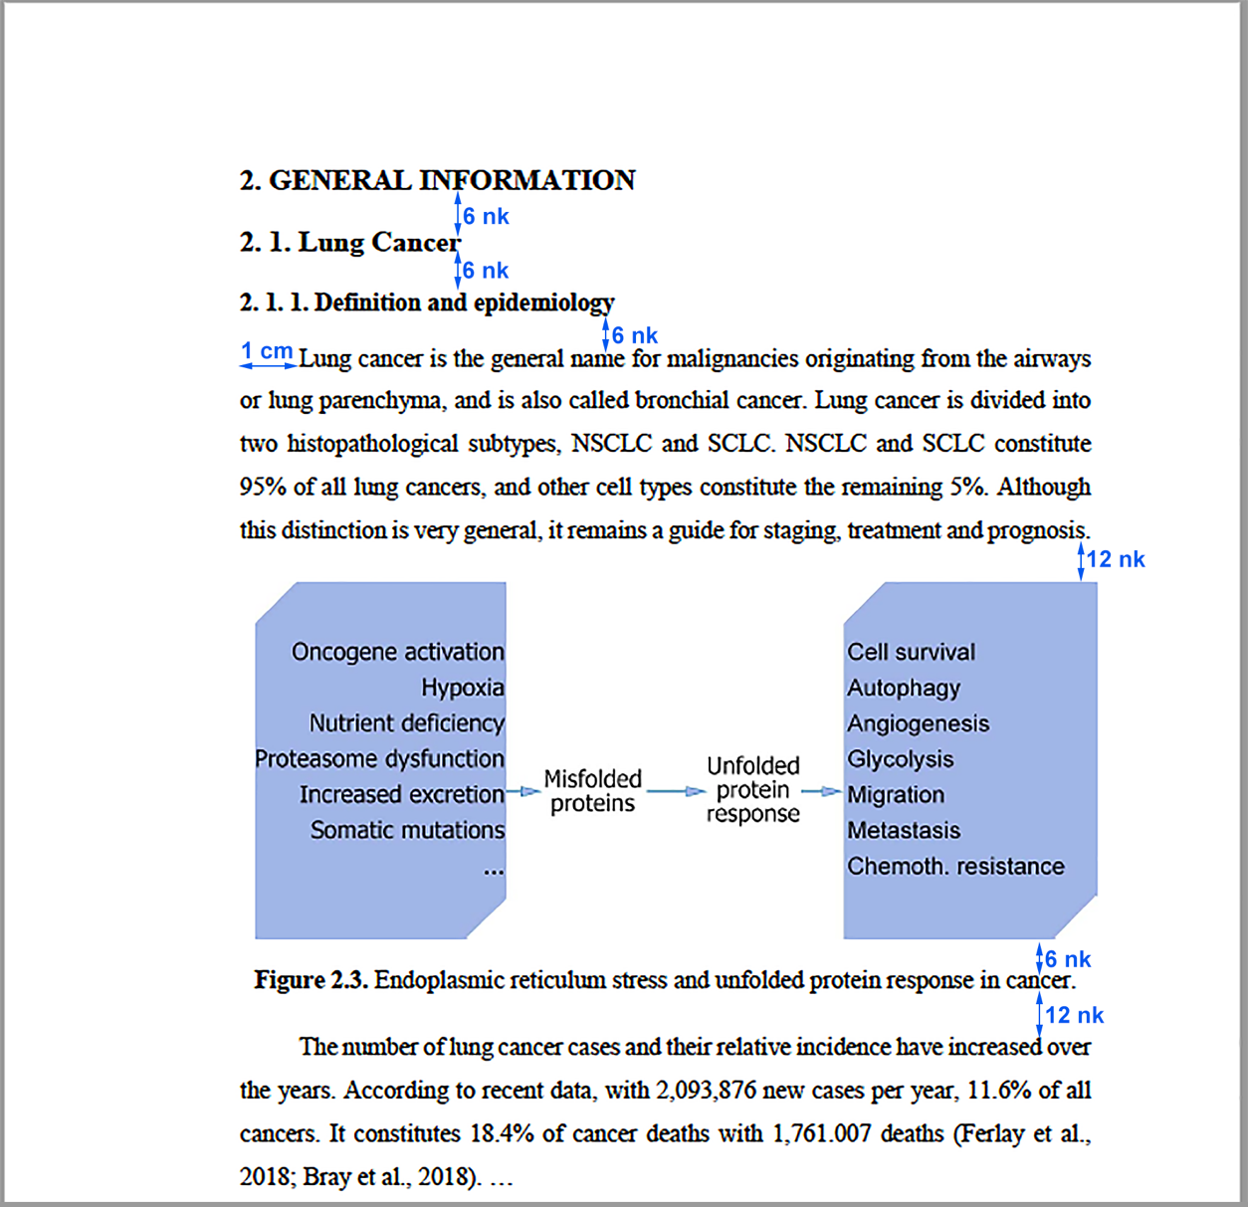
Figure 3.2. Line breaks before and after the title, text and figure.
3.6. Icons and Abbreviations
Abbreviations in the dissertation should be used in scientific form, but only when necessary, and the abbreviation should be explained only once, in parentheses, when it is first used in the text. In subsequent uses, the abbreviation should be used without explanation. For measurements, the metric system should be used and abbreviations should be given in accordance with the International System of Units. Abbreviations of units of measurement should be explained first, except for the well-known ones (cm, ml, etc.). For units of measurement, appropriate abbreviations (e.g., g, L) should be used in accordance with the International System of Units (https://www.bipm.org/en/measurement-units/). Units of measurement should not be placed at the end of the dot. Non-standard measures and abbreviations should not be used. Abbreviations that are not terms should be placed at the end of the dot. Abbreviations consisting of the initial letters of more than one word should not have a period between them (e.g., TUBITAK, ESOGU). Abbreviations should generally be formed according to the English terms, but very common abbreviations (such as AIDS, NATO, UNESCO) can be adopted as they are. Symbols and abbreviations used should be indicated separately in the index section.
3.7. Footnotes
When footnotes need to be given in a sentence, a straight line should be drawn at the bottom of the relevant page and a sign (*) should be placed to indicate the footnote, and an explanation should be written in 10 pt type. When tables and figures are used, footnote explanations should be written in 10 pt type directly below the table and figure.
3.8. Citations
If a section in the thesis containing more than one sentence from another source is to be quoted accurately, it should be written as a separate paragraph, in italics and in quotation marks (" "), after skipping a line from the last line of the main text. The text should be 2 cm from both sides of the main text. When you go to the main text after the quotation, another line should be skipped.

4. SECTIONS OF THE THESIS
The thesis consists of three parts:
A. Front part
- Outer cardboard cover (example: APPENDIX -1)
- Inner cover (example: APPENDIX -2)
- Acceptance and approval page (example: Appendix-3)
- Ethical Statement
- Acknowledgement page
- Abstract
- Abstract (Turkish)
- Index
- Table Index
- Index of Figures
- Index of symbols and abbreviations
B. Main Part
- 1. introduction and purpose
- 2. general information
- 3. materials and methods
- 4. results
- 5. discussion
- 6. conclusion and recommendations
C. Concluding chapter
- 7. list of references
- 8. list of appendices
- 9. curriculum vitae in table form
4.1. Front Section
4.1.1. Outer cover
The outer cover should be prepared according to the example in Figure 1.
4.1.2. Inner cover
The inner cover should be prepared according to the example in Figure 2.
The content and layout of the inner cover must be the same as the outer cover. The inner cover page should be written on the same paper as the main text and the page number should not be included. However, unlike the inner cover page, a blank page should be left between the name of the supervisor (second supervisor, if applicable) and the outer cover page and the inner cover page, and between the last page of the dissertation and the back of the outer cover page.

4.1.3. Acceptance and confirmation page
The acceptance and confirmation page should be prepared according to the example shown in the figure below. The acceptance page is the page that shows that the dissertation advisor and judges have accepted the dissertation after the dissertation defense and that the dissertation has been approved by the Health Sciences Institute. This page should have the titles, names, and institutions of the judges; it should be arranged by number of judges; and it should have the signatures of the judges. This page is added to the dissertation after the candidate has successfully defended the dissertation, made the necessary corrections in the dissertation, and it has been signed by the jury members in blue pen. When writing the name of the dissertation, only the first letters of each word (except for a special name, an abbreviation) should be written in capital letters and should not be bold.
Even if the dissertation is approved by the majority of votes, the approval and release page must bear the signature of all the jury members who conducted the examination, and the jury members who disagree with the decision must submit their reasons in a separate report to the Directorate of the Institute of Health Sciences. Final versions of the dissertation must be delivered to the judges and the Graduate School.
Note: While dissertations are uploaded to the National Thesis Center's Thesis Automation System, the juror's signature page will be removed from the dissertation as indicated in the decision below.
In the YÖK Board meeting held on 13/05/2020, it was decided that in order to protect personal data, it is appropriate to upload doctoral theses uploaded by institutes to the National Thesis Center Thesis Automation System without the "Thesis Approval Page" which contains the personal data and wet signatures of the jury of the doctoral thesis. This decision was communicated to all universities by the letter of the Council for Higher Education dated 03.06.2020, number 32794.
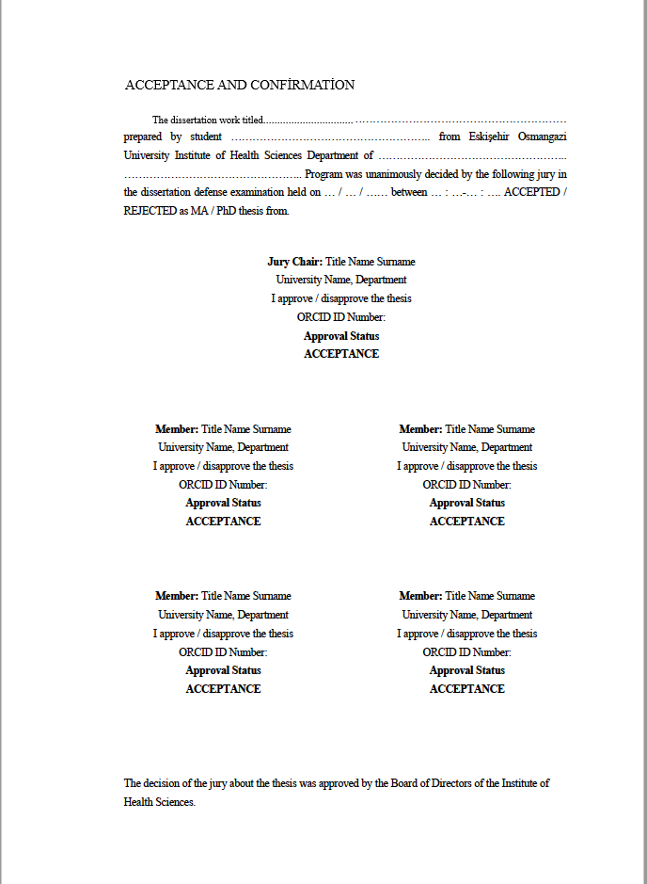
Figure 4. Acceptance and confirmation page

4.1.4. Ethical Statement
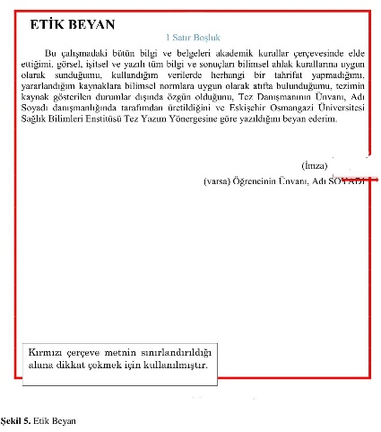
Figure 5. Ethical Statement
4.1.5. Acknowledgement page
Acknowledgement page will be included if requested. The Acknowledgements Page is the page on which thanks are given to the persons and/or institutions that have assisted in the writing and editing of the thesis. The title "ACKNOWLEDGEMENTS" should be in capital letters, 2,5 cm below the top of the page, left on the of the page and bold (bold). When writing the acknowledgements page, a font size of 12 and line spacing of 1.5 should be used, it should be written in simple language and concisely, and should not be longer than one page. It is written with the beginning of the paragraph. At the end of the letter of appreciation, the student's name and last name should be added to the right side of the page, and the date should be written in the middle below the student's name and last name.
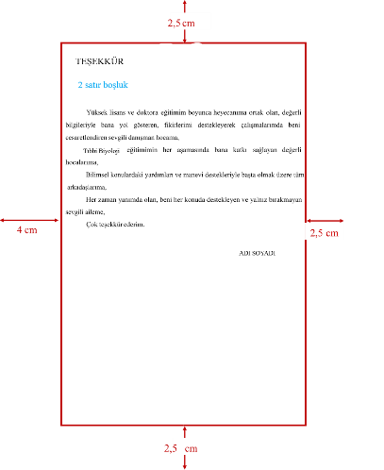
Figure 6. Acknowledgement page

4.1.6. Abstract and Turkish Abstract
The purpose of the abstract is to give the reader a brief overview of the entire thesis. English and Turkish abstract pages should appear one after the other. The abstract should be written with 1.5 line spacing, 12 font size, maximum 250 words and justified.
Abstracts,
- Title,
- Objective,
- Method,
- Results,
- Conclusion,
- Keyword information should be included.
The information in the abstract should reflect the scientific results of the work by writing the names of the above sections in capital letters and bold, in an order that ensures the readability and citability of the work. No references are given in the abstract, and there is no discussion.
There should be at least 3-4 keywords related to the topic at the end of the abstract.
Writing abstract,
- The problems/objectives under question are taken from the introduction,
- The characteristics of place, time and unit of study have been taken from the Materials and Methods section,
- The methods (research, data collection, data analysis, etc.) and research sequence used to achieve the objectives are taken from the Method section,
- The main findings and analysis results are taken from the Results section,
- The scientific contribution of the research should be prepared by taking the comments, judgments, generalizations and suggestions for the researchers from the Discussion and Conclusion section.
- In the Summary section, there is no judgment about a problem that has not been addressed or studied in the research.
At the end of the summary text, after 1.5 spaces, the title "Key Words" should be made up in bold type and continued on the same line, with the key words or phrases that relate to the thesis (maximum 5 words or phrases) separated by commas and the initials lowercase. The keywords should also be consistent with the "Medical Subject Headings" (MeSH).
The literal English translation of the Turkish abstract should be under the heading 'ABSTRACT'. It should be written in the language of the science to which it belongs. The terms and terminologies should be chosen for the particular field. Title and keywords should also be written in English.
Turkish and English abstracts should be written as shown in Figure 7. and Figure 8.
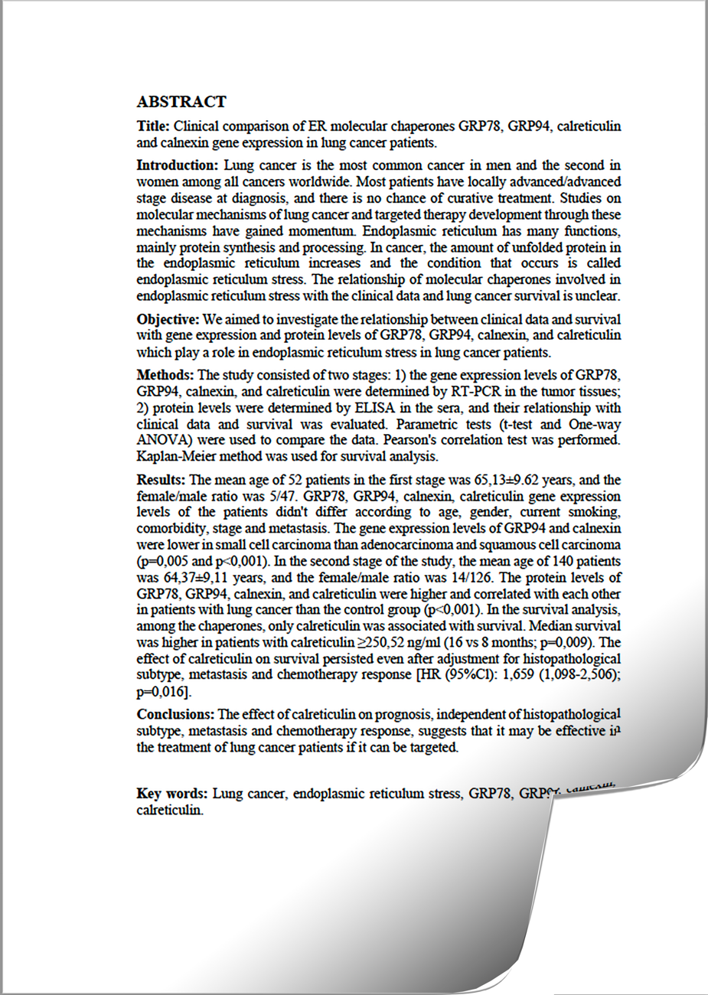
Figure 7. English abstract example.
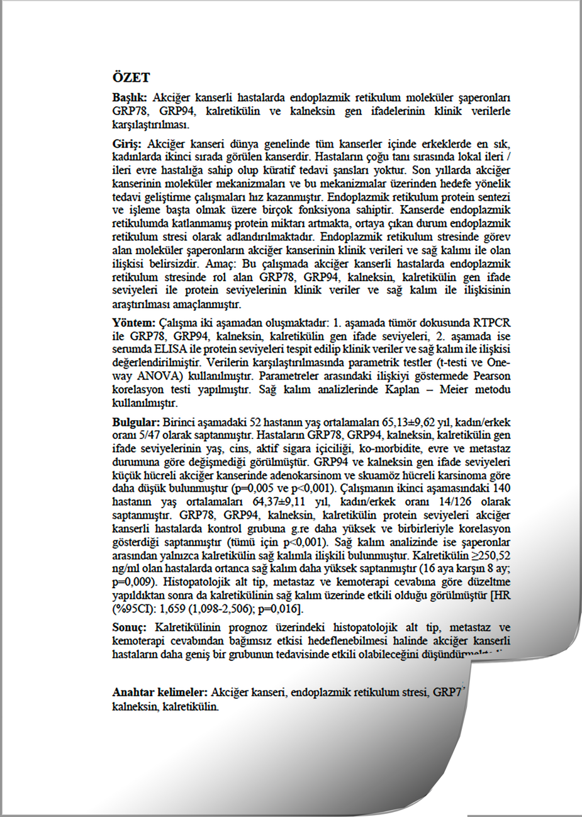
Figure 8. Turkish abstract example.

4.1.7. Indexes
4.1.7.1. Tables of contents
Beginning with the abstract page, all special pages should be given in full in the order of passage in the dissertation. All chapters and the titles of second and third subsections, references, and appendices in the text of the thesis should be included in the table of contents. If there is a section "APPENDIX" in the thesis, it should be placed at the end of the table of contents, but the page numbers should not be included in the index.
Any title used in the paper should be included in the table of contents without change. The title "TABLE OF CONTENTS" should be written in capital letters, 2,5 cm below the top of the page, bold and flat to the left. The number of the first page containing only this title should be written in line with each heading of the table of contents.
- First degree chapter headings should be in capital letters, 14 pt, and bold,
- In second-degree subchapter titles, the first letter of each word is capitalized and the others are in 12 pt, lowercase.
- In third-degree and higher subsection titles, the first letter of the first word should be capitalized, and all other words should be lowercase in 12 pt.
- - In fourth-degree and higher subsection titles, the first letter of the first word should be capitalized, and all other words should be lowercase and italicized in 12 pt.
- If subsection headings do not fit on the first line, they should begin on the line where the title begins and be moved to the bottom line before the first line reaches the page number.
If desired, you may use 10 or 11 pt in the table of contents.
Line spacing must be 1,5 space.
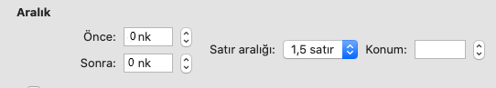
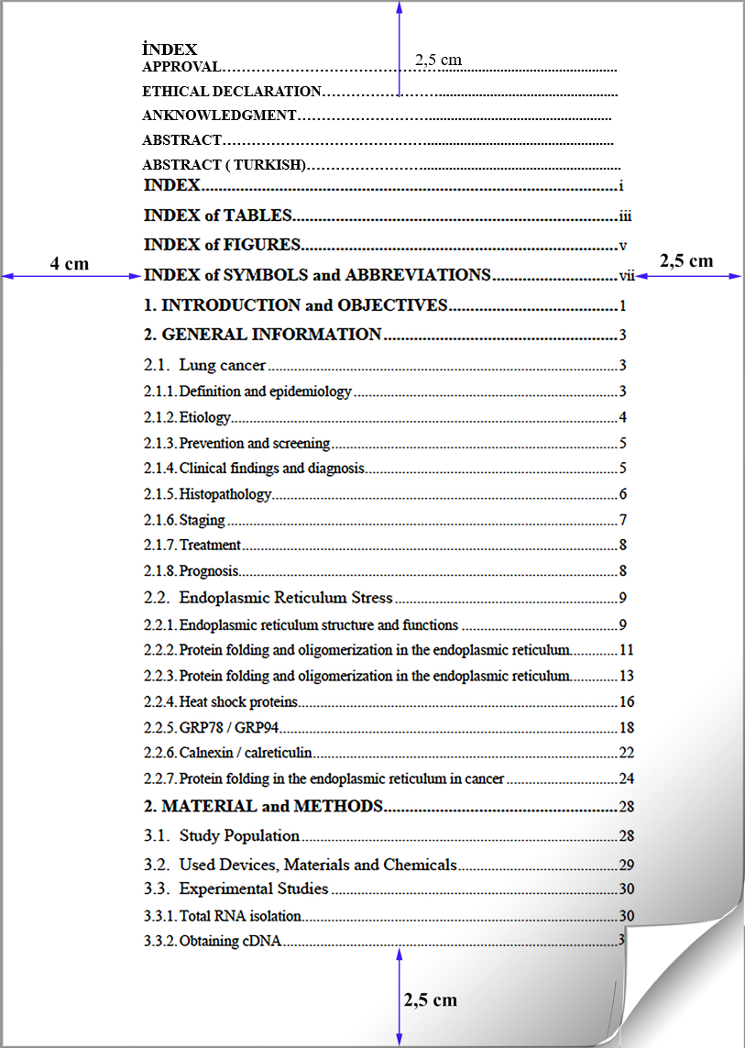
Figure 9. Example of index, shape and form.
4.1.7.2. Index of symbols and abbreviations
The title "SYMBOLS AND ABBREVIATIONS" should be written in capital letters, 2,5 cm below the top of the page, left and bold.
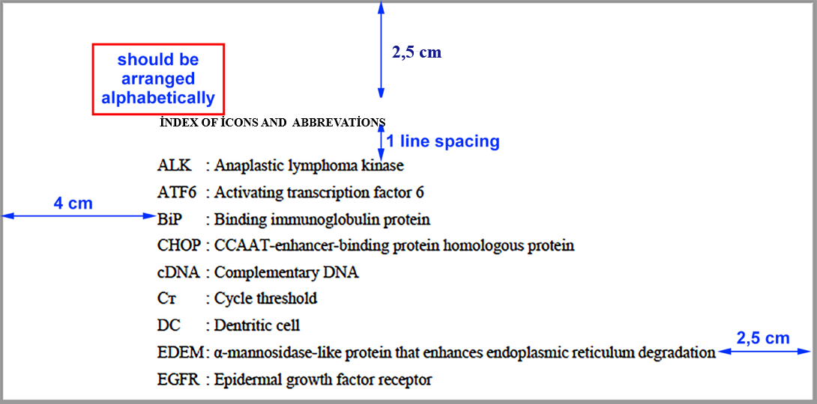
Figure 10. Example of index of icons and shape and form.
4.1.7.3. Index of illustrations
The title “DRAWINGS” should be written in capital letters, 2.5 cm below the top of the page, to the left and in bold. The figure index should list the figure titles exactly as they appear in the thesis.
- If the text of the figure captions does not fit on the first line and goes on the bottom line, the caption should begin on the line where the text begins and go on the bottom line before the first line reaches the page number. The number of the page on which the figure is located should be right-justified next to the name of the figure.
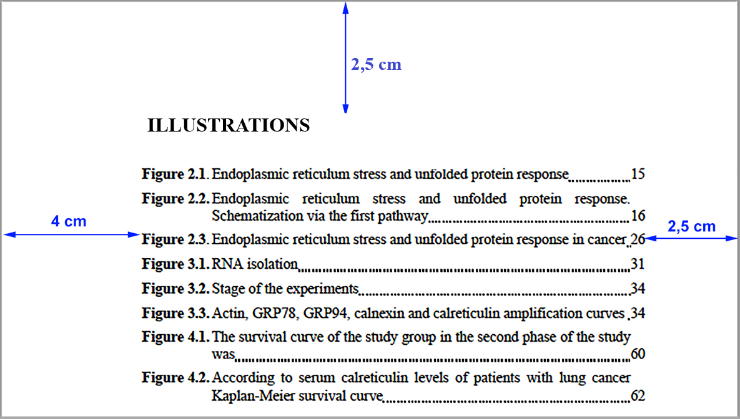
Figure 11. Example of index of illustrations, shape and form.
4.1.7.4. Index of tables
The title "TABLES" should be in capital letters 2,5 cm below the top of the page, flat to the left and bold. In the table index, the table headings should be listed exactly as they appear in the thesis.
- If the table headings do not fit on the first line, they should be moved to the bottom line before the first line reaches the page number. The number of the page on which the figure in question is located should be right-justified opposite the name of the table. If the table is longer than one page, only the number of the first page should be given.
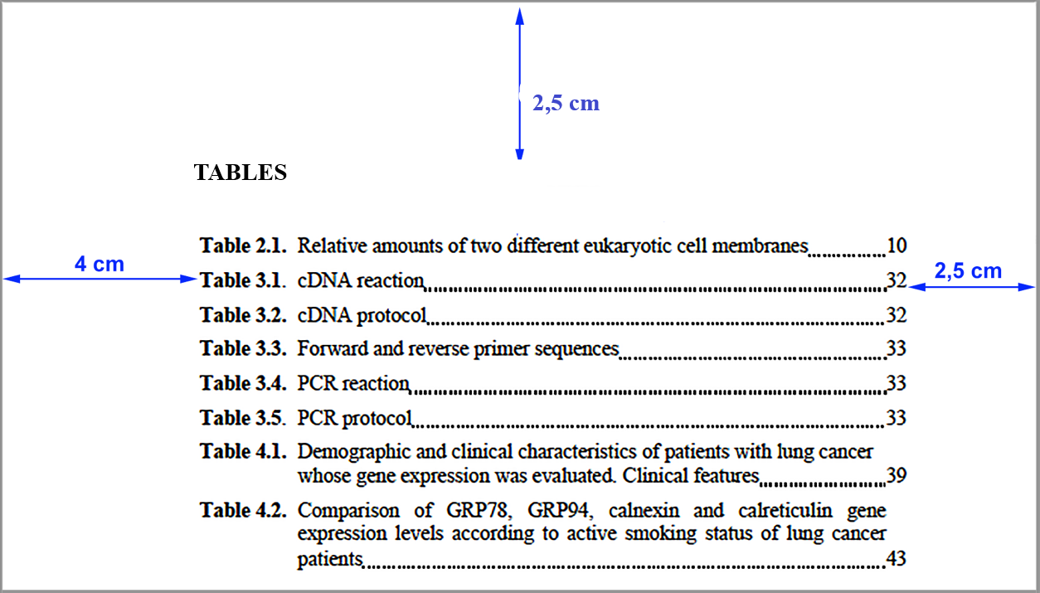
Figure 12. Example of index of tables, shape and form.
4.2. Main Section
4.2.1. Introduction and Aim Section
In the introduction and aim section, the definition and meaning of the problem and the purpose of the research should be stated briefly, clearly and understandably. General information about the research should be given, the topic should be defined and why the research should be conducted should be explained. The importance of the research topic in the literature, its background, current situation, problems encountered and gaps that need to be filled should be clearly highlighted. The significance of the research, its contribution to science, art, practice, humanity, world and our country, benefits and dimensions should be explained. Hypotheses and/or research questions for solving the problem should be formulated.
4.2.2. General Information Part
Information from literature that is closely related to the topic of the dissertation should be presented in a specific order, it should contain current research results and not classical information, and unnecessary and excessive accumulation of information should be avoided. General information found in classic books should not be included in this section. The general information section should not exceed 25% of the entire dissertation in terms of page count,
The information should be presented in historical order. The reader should present the development of previous work, the issues that have been resolved and new problems that have arisen, and the variables and approaches that have been extensively studied. The information to be used should be taken from the original source; secondary sources should not be used for this purpose. This section should not be in the style of a catalog of references. Existing information should be evaluated using an analytical and critical approach.
4.2.3. Material and Methods Section
This section should clearly write where, when and with how many people the research was conducted so that it can be carried out by another researcher.
4.2.3.1. Ethics Committee Approval of the Study
All dissertations must be approved by the appropriate ethics committee. This section will indicate the date and number of the ethics committee approval and the approval of the institution from which it was obtained. The ethics committee documents and, if required, the institution's approval should be attached.
4.2.3.2. Nature of the research
The type of research design (descriptive, cross-sectional, case-control, cohort, experimental, methodological, secondary research, etc.) should be indicated.
4.2.3.3. The population and sample/study groups of the research.
The society and sample from which the research units (individual, volunteer, patient, control, etc.) were selected should be stated. The population of the study should be defined. If a sample is drawn for the study, the selection methods used (random, systematic, stratified, cluster, non-probability sampling) should be stated. The calculations for the sample size should be written down.
The characteristics of the study group, inclusion, exclusion and exclusion criteria should be stated.
4.2.3.4. Research procedures
The study (if any) should specify what the study material is (cell line, experimental animal, human serum, urine, tissue sample, etc.), where, how, and when it was collected. Information should be provided on how the experiments were conducted.
Brands, companies and sources, batch numbers, intended use, etc. of tools, vehicles, drugs and substances used must be given in a specific order.
The method(s) used (research method, clinical and experimental method, data collection method, etc.) should be stated. The method/methods should be clearly stated, understandable and contain the necessary details so that they can be accurately applied by another researcher if they are classical methods.
Since it is not always possible to use the most appropriate methods in data collection, the advantages and disadvantages of the chosen methods should be stated and the reasons for their choice should be discussed.
The methods should be explained in detail and references to each method should be provided. All the studies and methods used in the research should also be given in the form of flow chart. (Fig. 13.)
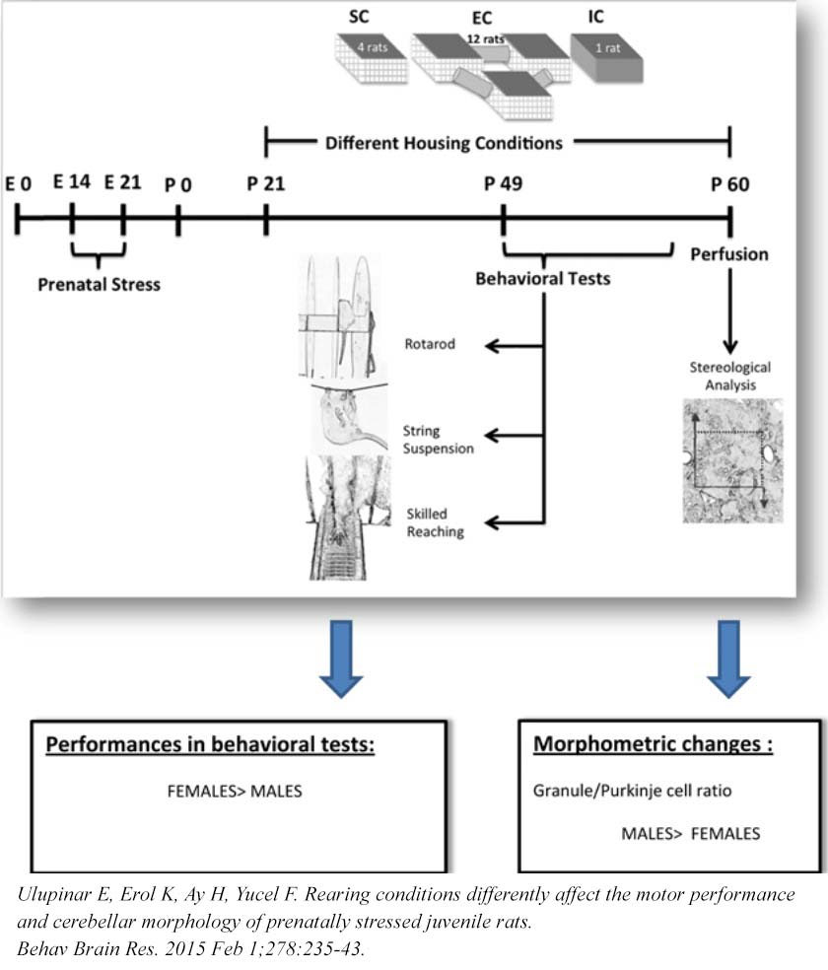
Figure 13. Example of graphical abstract.
The date of data collection, the data collection instruments, and the person who created the data collection instruments (scale, survey questionnaire, survey form, etc.) should be included, if necessary, with the source cited.
4.2.3.5. Variables of the study
The dependent and independent variables of the study should be described. Definitions of the variables should be made, citing the literature.
4.2.3.6. Analysis of the data
The methods of analysis and the data analysis package program used in the statistical analysis of the research data should be stated. The reasons for the choice of statistical methods used in the analysis of the data and their appropriateness (in terms of the objective sought) should be discussed. Words such as "important/significant" should be used in interpretations based on statistical analysis. The statistical methods used in the data analysis must be up to date and the source of the methods used must be cited. The statistically significant limit accepted for p must be stated.
4.2.3.7. Limitations of the study
The changes that the researcher had to make to the research plan and the procedures that he had to forgo for various reasons should be listed in this section.
4.2.4. Results section
The results of the study should be stated clearly and concisely. Discussion and comments should not be included in this section. The results of the analysis of the data obtained from the study should be presented clearly and regularly in accordance with the purpose of the study. They should be organized according to the research question and/or hypotheses and presented in a certain logical analytical integrity and flow. The calculation of indicative statistics, the preparation of tables, graphs and figures, and the presentation of data should conform to international publication standards.
Where necessary, figures, tables, photographs and graphs should be used in the presentation of results. The same data in tables, figures and other visual materials should not be presented in more than one format (e.g., both tables and graphs).
Photographs must be in formats such as TIFF, JPEG, 300 dpi quality and numbered as "shapes". When using case photos, the eyes may be masked to avoid revealing the identity of the subjects. For the use of photos without masks in special cases, a signed permission of the person photographed must be obtained and indicated below the photo.
4.2.5. Discussion Section
The Discussion section is the section that discusses the ways in which the problem was solved, the generalizable judgments that were obtained from the research, and the validity and reliability of those judgments. This section should avoid repetition of information from the introduction and the results section.
The discussion section should be written in a manner that compares the scientific findings/results obtained from the research with the findings in the sources used, scientifically demonstrating the reasons for the similarities and differences and determining the general judgments obtained from the research and their contributions to science and practice using the information in the literature.
The discussion section should be written in accordance with the order of presentation in the findings section. Repetition of results and speculative interpretations should be avoided.
The discussion section presents scientific assessments of the research topic and states the benefits of the research and its contribution to science and practice. Any result not included in the research and not apparent from the results should not be presented as scientific information.
4.2.6. Conclusion and Recommendations Section
The conclusion is a section that contains the latest findings from the research, suggestions and warnings for new researchers, and tips for future research. If necessary, the findings can be written down point by point. This section provides information on the extent to which the purpose of the research has been achieved, based on the results of the study (without repeating the results section).
The scientific findings that result from the objective data obtained as a result of the study should be briefly presented. Suggestions that increase the scientific contribution of future research on this topic should be included in the conclusions and recommendations section.

4.3. LAST SECTION
4.3.1. References
In this section, the works of authors and scholars whose ideas and research we use in this research are arranged in alphabetical order. All works in this index must be included (cited) in the text.
References to images, figures, and graphs in the text should be included in the index. Oral or written interviews will not be included in the index.
The first lines of references in the index should begin at the left margin and the second and next lines should begin within 1 (cm) tab.
Single spacing should be left between lines of a source.
There should be a blank line between references.
References should be arranged alphabetically by authors' last names and should not be numbered. If there are multiple sources by the same author in the bibliography, the sources are written in order from old date to new date. Sources with the same date are sorted by letter. Even if the publication of authors with the same last name is older, the first letter of the name is given first in the bibliography, which is first in alphabetical order.
References should be written in the original language in which they were published. If the bibliography is longer than one page, the list should continue with the heading "REFERENCES (continued)" at the top of the next page.
References should be cited in the text and in the bibliography according to the spelling rules APA 7.0 listed below.

4.3.1.1. Insertion of references in the text (citation format):
- If there is a general reference in the text and it refers to the whole text (author's surname, year), it is sufficient to write it.
… olduğu düşünülür (Öztürk, 2004).
… bu durumda iki yol izlenir; (Öztürk, 2004)

- When a particular page is cited or related ideas are taken from a particular section, the source is given with the page as follows:
(Köker, 1998, s. 42; Aydın, 2010, s. 42-54).
- The works of an author of the same date are written as follows:
(Zizek, 2009a) ve (Zizek, 2009b).

- If the number of authors is more than two, it is sufficient to give only the first author in each reference. For example, Kejanlıoğlu, Adaklı & Çelenk, 2004 appear only as (Kejanlıoğlu et al., 2004) in each occurrence.
- When a source with two authors is referenced in the text, the names of both authors are given each time.
- When a source is referenced that cites secondary sources, the primary source is referenced. For example (referring to Zizek, Sancar, 2009). Sancar (2009) is included in the reference list with all imprints, but Zizek's source is not cited.
- For example, if the primary source cited in the secondary source used in the text was never read by the author of the article, the problem in Zizek's conception of ideology is stated as (cited in Zizek, Sancar, 2009).
- Information based on email (e-mail), telephone, and personal conversations is not included in the resource list without providing a bibliography.
- Classic books are shown in the format (author's last name, date) if the publication date is known.
(Gray 1858)

- If you quote directly from the original work, the extracted word(s)/phrase(s) will be marked by three dots "...".
Farkındalık kelimesi, “içeriğe bağlı olarak çeşitli anlayışları ileten bir eğilim kelimesi haline geldiği için bir dizi anlama sahiptir ve çeşitli ....” (Crane, 2017, s.586)
Crane'in (2017) dediği gibi, “farkındalık, içeriğe bağlı çeşitli anlayışları aktaran bir eğilim kelimesi haline geldi ve çeşitli ....” (s. 586)

- Other short and direct quotations in the text are written with double quotation marks. Double quotes are not enclosed in double quotation marks.
Kramer anılarında “Crane ‘farkındalık kelimesi, içeriğe bağlı çeşitli anlayışları aktaran bir eğilim kelimesi haline geldi’ ifadesini her platformda dile getirirdi.” demiştir.

- Double quotation marks are also used to indicate the title of a journal or book article in the text.
- The first time a technical term is used, the word is italicised; subsequent uses use the normal writing style.
- When abbreviations are used for the first time in the text, they are enclosed in parentheses and used in the normal writing style in subsequent uses.
- When importing from a web document without a page number, the paragraph number must be included. For example: (Dursun, 2009, para. 10).
- When a source is cited as a block in the text, the left margin of the cited paragraph is started 1 cm from the main text.
Bugün, dijital kameralar pratik olarak fotoğrafçılığı ele geçirdi. Johnson'ın (2010) açıkladığı gibi,
Dijital kameralar artık önde gelen elektronik mağazalarındaki tüm kamera satışlarının %90'ını oluşturuyor. Satışlardaki bu artış, kısmen dijital fotoğrafların paylaşılmasını teşvik eden e-posta ve sosyal ağın yaygın kullanımına bağlanabilir. (s. 23)
Johnson ayrıca, dijital kameralara geçişten bile daha fazla, dahili kameralara sahip telefonların ve ipod’ların artan kullanımının film kameralarının kullanımının yerini aldığını belirtti.

4.3.2.2. Writing the References in the Bibliography Index
Single authored book;
Author Surname, Author Name Initial. (Year). Book Title (italic), edition, Publisher.
Jackson, L. M. (2019). The psychology of prejudice: From attitudes to social action (2nd ed.). American Psychological Association. https://doi.org/10.1037/0000168-000

Sapolsky, R. M. (2017). Behave: The biology of humans at our best and worst. Penguin Books.

Books with more than one author;
First Author Surname, First Author Name Initial., Second Author Surname, Second Author Name Initial., … & Last Author Surname, Last Author Name Initial. (Year). Book Title (italic), edition, Publisher.

Myers, T. W., Juhan, D., & Chaitow, L. (2009). Anatomy Trains: Myofascial Meridians for Manual and Movement Therapists. (2nd ed.). Churchill Livingstone Elsevier.

Svendsen, S., & Løber, L. (2020). The big picture/Academic writing: The one-hour guide (3rd digital ed.). Hans Reitzel Forlag. https://thebigpicture-academicwriting.digi.hansreitzel.dk/

Edited book;
Author Surname, Author Name Initial. (Ed.). (Year). Book Title (italic), edition, Publisher.
Kayaalp, S. O. (Ed.). (2012). Akılcıl Tedavi Yönünden Tıbbi Farmakoloji 1. Cilt (13. Baskı). Pelikan Yayıncılık

Easton, T. A. (Ed.). (2008). Taking sides: Clashing views in science, technology and society (8th Ed.). McGraw-Hill.

Torino, G. C., Rivera, D. P., Capodilupo, C. M., Nadal, K. L., & Sue, D. W. (Eds.). (2019). Microaggression theory: Influence and implications. John Wiley & Sons. https://doi.org/10.1002/9781119466642

Chapter in an edited book;
Dear, J., & Underwood, M. (2007). What is the role of exercise in the prevention of back pain? In D. MacAuley & T. Best (Eds.), Evidence based sports medicine (2nd ed., pp. 257-280). Blackwell.

Kayaalp, S. O. (2012). Akılcıl tedavi yönünden tıbbi farmakoloji 1. Cilt. (Ed.), Genel Farmakoloji, Farmakokinetik ve Toksikoloji içinde (s. 7-154). Pelikan Yayıncılık

Electronic printed book only;
Schiraldi, G. R. (2001). The post-traumatic stress disorder sourcebook: A guide to healing, recovery, and growth [Adobe Digital Editions version]. https://doi.org/10.1036/0071393722

Book with unknown publication date;

Book with unknown publication date;
O'Keefe, E. (n.d.). Egoism & the cnsts in Western values. Erişim http://www.onlineoriginals.com/showitem.asp item I 135

Sources obtained from an electronic address;
The URL where the resource can be accessed is given. Author Surname, Author Name Initial. (Year). Book Title (italics). If available, edition, Internet access link
Rosner, B. (2005). Fundamentals of Biostatistics. (8th ed.) http://books.google.com.tr/books?id=-CQtWiJJL0cC&

Ministry of Health. (2008). Drug policy in New Zealand. http://www.moh.govt.nz/moh.nsf/wpg_index/About-drugs

Articles;
If applicable, the entire Digital Object Identifier (DOI) address must be specified.
Author Surname, Author Name Initial. (Year). Article Name (italics). If available, edition, Internet Access Link. Internet Download Date. (If there is a DOI address, the access link and download date will not be written, the DOI address will be written).

Articles with a single Author
Yılmazel, G. (2013). Hemşirelerde Psikolojik Yıldırma, İş Doyumu ve Etkileyen Faktörler. 5(2):55-63. http://www.turkiyeklinikleri.com/article/tr-hemsirelerde-psikolojik-yildirma-is-doyumu-ve-etkileyen-faktorler-66094.html

Cerasoni J. N. (2021). Vectorial application for the illustration of archaeological lithic artefacts using the "Stone Tools Illustrations with Vector Art" (STIVA) Method. PloS one, 16(5), e0251466. https://doi.org/10.1371/journal.pone.0251466

Articles with more than one author;
For a work with up to 20 authors, all names are included in the reference. When the number of authors is 21 or more, the names of the first 19 authors are added, the last author’s name is written after the ellipsis is added.
Sample:
Author, A. A., Author, B. B., Author, C. C., Author, D. D., Author, E. E., Author, F. F., Author, G. G., Author, H. H., Author, I. I., Author, J. J., Author, K. K., Author, L. L., Author, M. M., Author, N. N., Author, O. O., Author, P. P., Author, Q. Q., Author, R. R., Author, S. S., . . .Author, Z. Z. (Year). Article title (italics). Journal name, issue (volume number), page numbers. DOI address.
Wiskunde, B., Arslan, M., Fischer, P., Nowak, L., Van den Berg, O., Coetzee, L., Juárez, U., Riyaziyyat, E., Wang, C., Zhang, I., Li, P., Yang, R., Kumar, B., Xu, A., Martinez, R., McIntosh, V., Ibáñez, L. M., Mäkinen, G., Virtanen, E., . . . Kovács, A. (2019). Indie pop rocks mathematics: Twenty One Pilots, Nicolas Bourbaki, and the empty set. Journal of Improbable Mathematics, 27(1), 1935–1968. https://doi.org/10.0000/3mp7y-537

Dzinamarira, T., Mhango, M., Dzobo, M., Ngara, B., Chitungo, I., Makanda, P., Atwine, J., Nkambule, S. J., & Musuka, G. (2021). Risk factors for COVID-19 among healthcare workers. A protocol for a systematic review and meta-analysis. PloS one, 16(5), e0250958. https://doi.org/10.1371/journal.pone.0250958

Evci, C., Oral, H. B. (2004). Granülomatöz Enfeksiyonlara Karşı Bağışıklamada Yeni Gelişmeler: Tüberküloz Modeli. 3(3):97-106. http://www.turkiyeklinikleri.com/article/tr-granulomatoz-enfeksiyonlara-karsi-bagisiklamada-yeni-gelismeler-tuberkuloz-modeli-34425.html

Articles with only article numbers;
Jerrentrup, A., Mueller, T., Glowalla, U., Herder, M., Henrichs, N., Neubauer, A., & Schaefer, J. R. (2018). Teaching medicine with the help of “Dr. House.” PLoS ONE, 13(3), Article e0193972. https://doi.org/10.1371/journal.pone.0193972

Reports and technical articles;
Russo, C. A., & Jiang, H. J. (2006). Hospital stays among patients with diabetes, 2004 (Statistical Brief No. 17). Erişim: Agency for Healthcare Research & Quality website: http://www.hcup-us.ahrq.gov/reports/statbriefs/sb17.jsp

Dissertations;
Kabir, J. M. (2016). Factors influencing customer satisfaction at a fast food hamburger chain: The relationship between customer satisfaction and customer loyalty (Publication No. 10169573) [Doctoral dissertation, Wilmington University]. ProQuest Dissertations & Theses Global.

Miranda, C. (2019). Exploring the lived experiences of foster youth who obtained graduate level degrees: Self-efficacy, resilience, and the impact on identity development (Publication No. 27542827) [Doctoral dissertation, Pepperdine University]. PQDT Open. https://pqdtopen.proquest.com/doc/2309521814.html?FMT=AI

Zambrano-Vazquez, L. (2016). The interaction of state and trait worry on response monitoring in those with worry and obsessive-compulsive symptoms [Doctoral dissertation, University of Arizona]. UA Campus Repository. https://repository.arizona.edu/handle/10150/620615

Kızıl, Ş. (2013). Tekrarlayan gebelik kaybı olgularında endometriyal reseptivitede adezyon ve anti-adezyon molekülleri ile transkripsiyon faktörlerinin araştırılması [Yüksek Lisans Tezi, Ankara Üniversitesi Sağlık Bilimleri Enstitüsü]. YÖK Ulusal Tez Merkezi. https://tez.yok.gov.tr/UlusalTezMerkezi/TezGoster?key=1zw6GvYMe-q3Hf6HR-3US-KdOAeU59b0QVf5nH8q6uxusrHzKjxVcEaaaVPetD7I

Özden, H. (1995). Omurga’nın Torakal Bölümü’nde medulla spinalis çaplarının manyetik rezonans görüntüleme (MRG) tekniği ile ölçümü ve değerlendirilmesi [Doktora Tezi, Eskişehir Osmangazi Üniversitesi Sağlık Bilimleri Enstitüsü]. Eskişehir Osmangazi Üniversitesi Kütüphanesi.

Encyclopedias or Dictionaries;
Vernix caseosa. (2009). In D. Venes (Ed.), Taber's cyclopedic medical dictionary (21st ed.) [STAT! Ref version]. Erişim: http://online.statref.com

Diabetes. (n.d.). In Merriam-Webster's online dictionary (11th ed.). Erişim: http://www.merriam-webster.com/dictionary/diabetes

Published papers presented at a symposium/congress;
Hayat, E. A., Türe, M., Şenol, Ş. (2013, 20-23 Ağustos). Çok Boyutlu Sağ Kalım Verilerinde Denetimli Temel Bileşenler Analizine Alternatif Bir Boyut İndirgeme Yaklaşımı, 15. Biyoistatistik Kongresi Bildiri Kitapçığı, s 30. Aydın, Türkiye.

Duckworth, A. L., Quirk, A., Gallop, R., Hoyle, R. H., Kelly, D. R., & Matthews, M. D. (2019). Cognitive and noncognitive predictors of success. Proceedings of the National Academy of Sciences, USA, 116(47), 23499–23504. https://doi.org/10.1073/pnas.1910510116

Appendices:
This section is created optional. In the Appendices section;
- Chemical expansions of drugs used,
- Any scales used (e.g. surveys used), etc.
- Clear formulas, generic names of chemicals used in the research,
- Additional explanations of methods,
- Proofs of some mathematical and statistical procedures and formulas,
- Computer programs used in data analysis that are not included in the usual packages,
- program or macro codes,
- maps of the research area, sketches,
- raw data,
- Information such as additional photographs (e.g., radiographs used) should be included.
Each appendix in this section should start on a new page, each appendix should have a title, be numbered with a different number (e.g. APPENDIX -1, APPENDIX -2, APPENDIX -3...) and be included in the table of contents.
Eskişehir Osmangazi College, where the dissertation was submitted, Health Sciences.
"Confirmation Page" (Appendix-3) with the names and signatures of the director of the institute and the members of the jury.
The page with the decision of the Ethics Committee should be given as Appendix-4 in the appendices of the dissertation.
Curriculum Vitae:
The page CV should be prepared as indicated in Appendix-4 to reflect the scientific and social identity of the person who prepared the dissertation (Master's/PhD student).
THESIS DISSERTATION
Before the dissertation defense examination
During the examination stage of the dissertation, the "Dissertation Writing Checklist" should be prepared and sent to the Institute with the signature of the supervisor along with 1 sample dissertation.
After the dissertation has passed the examination stage and the plagiarism report has been received, depending on the number of jury members, 6 or 8 copies must be prepared and distributed to the jury members and submitted to the Institute one month before the examination without any obligation.
After the dissertation is submitted, the date for the dissertation defense and the jury members are set and the dissertations are sent to the jury members.
After the dissertation defense examination.
Graduate or doctoral students must submit the following documents to the Graduate School.
1- The dissertation written according to the "Thesis Writing Rules", with cover/hard cover, wet signature (3 pieces).
2- The dissertation written according to specifications and put into pdf format, and 2 CD /DVDs with the reference number assigned by (the CD /DVDs will indicate the name of the institute, the name of the department, the scientific branch, the title of the dissertation), the master's/doctoral thesis and the year).
3- "Thesis Data Entry and Publishing Permission Form", 2 copies of Thesis Data Form with wet signature (can be downloaded from http://www.yok.gov.tr).
4- Copyright Transfer Document and Graduation Form, 2 copies of Copyright Transfer Document with handwritten signature (can be downloaded from http://www.yok.gov.tr).
The graduation form can be obtained from the Graduate School Student Affairs.
5- The "Thesis Writing Checklist" (Thesis Post-Exam Control Form), completed by the graduate student and signed by his/her advisor, must be submitted to the Institute.

4.3.2. Appendices

4.3.3. Resume

4.3.4. Thesis submission
4.3.5. Yayımlama ve fikri mülkiyet hakları beyanı
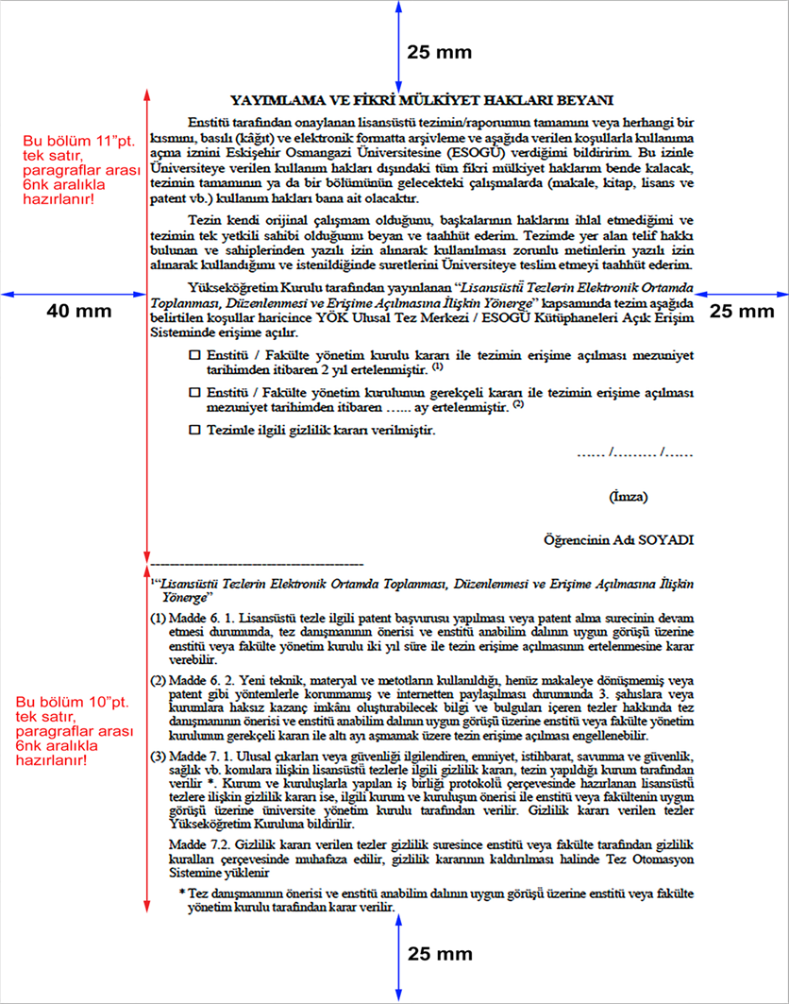
Şekil 15. Yayımlama ve Fikri Mülkiyet Hakları Beyanı

